Stage 2 – "That don't make no sense!"
COURSE DESIGNER: Adam Taylor
SCORING: Comstock 28 rounds.
TARGETS: 14 cardboard targets
SCORED HITS: 2 Best hits per carboard will be scored.

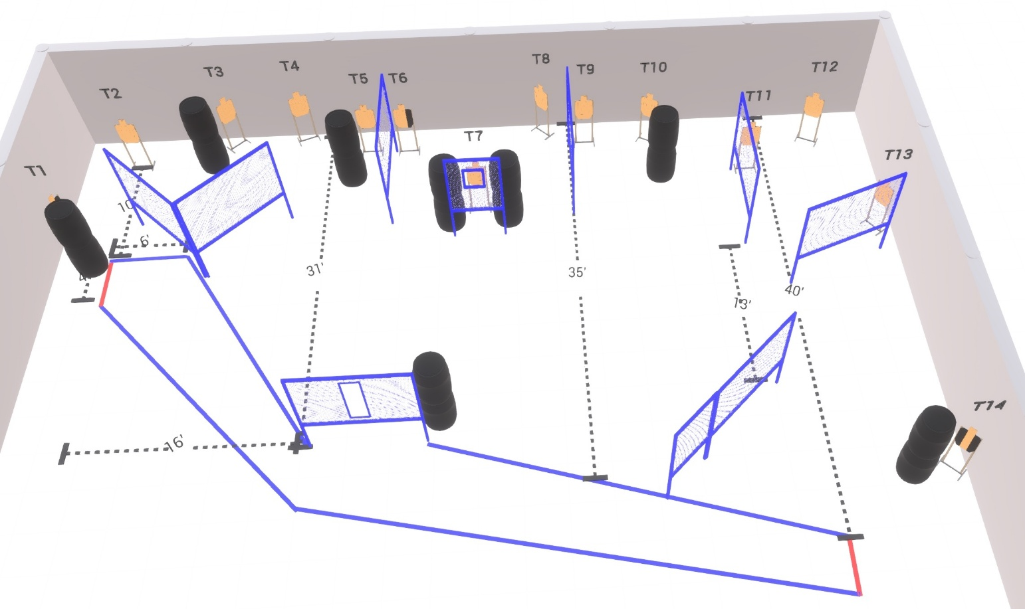

Written Stage Briefing:

Stage 2 – "That don't make no sense!" - is a 28 round, 140 point, Comstock Course. There are 14 cardboard targets.

Starting outside the shooting area with toes of both feet touching red one of the fault lines.
Handgun is loaded and holstered, wrists below belt.
PCC is loaded held in both hands, stock on belt.

On the audible start signal, engage targets from within the shooting area.

USPSA / NROI Range Commands:
- Make Ready
- Are you ready?
- Standby
- If finished, unload and show clear
- If clear, hammer down and holster (Handgun)
If clear, hammer down and flag (PCC)
If clear, cylinder closed and holster (Revolver)
- Range is clear

Setup Notes:
16 Single Wall Stands
2 Double Wall Stands
7 Full Walls
1 Port Walls
1 Half Port Wall
14 Target stands / 28 target sticks
16+ Barrels



